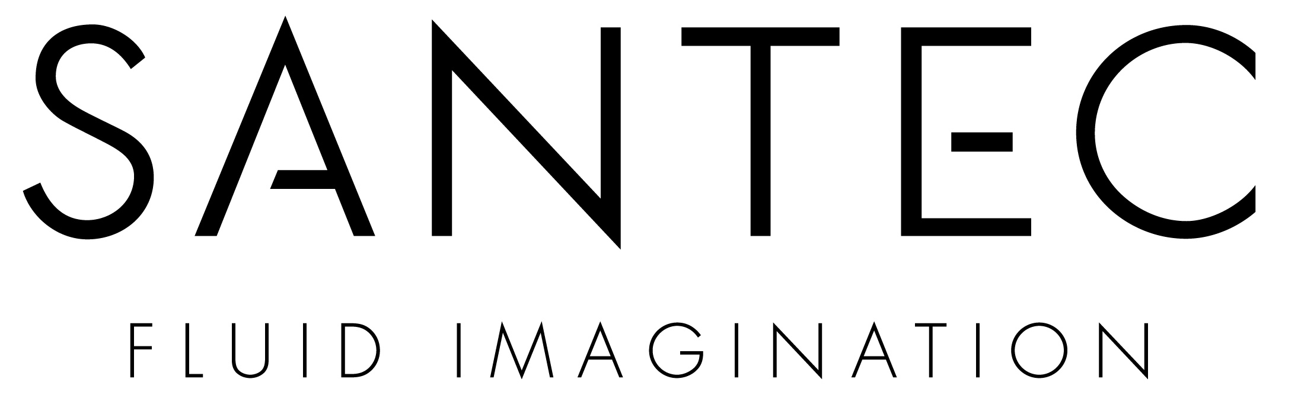

October 22, 2010

To our Valued Customers:

We have been discussing the idea of changing the name & number of our Oil Rubbed Bronze finish (49) in the Designer Series for some time. The reason for this possible change is that this finish is not like the industry standard for Oil Rubbed Bronze, it is more of a grey tone finish. The other issue is that when this finish is ordered by customers without looking at a display in the current ORB it is occasionally rejected by the customer (and returned).

We have decided that we will be making a “rolling” change on this finish over the next 2 ½ months in the field and will be changing this finishes name and number to Gun Metal Grey (#14). This will be a change that we will make in the Designer Series Price books at each location between now and Dec. 31st, 2010. Customer Service will still recognize both finish numbers up until that time as the same finish and process this accordingly.

We are sending our sales agencies new labels to update your materials in the field and affix on the finish chart in the Designer Price Guide and Finish Coin samples. If you are looking for “Oil Rubbed Bronze #49,” it is now called “Gunmetal Grey #14.” All future Designer Price books sent from the office and finish rings will have the #14 Gun Metal Grey in them instead of the #49 Oil Rubbed Bronze.

In regards to the display units that are on the walls at Showroom’s throughout the country, our sales agencies will identify these units and mark out the #49 and the Oil Rubbed Bronze finish name and replace it with the gun Metal Grey name and #14 on their next couple visits.

Oil Rubbed Bronze for Santec has never been our “industry comparable” Bronze finish. That has, and will continue to be, Roman Bronze. Roman Bronze has the more Matted Earth-Tone Bronze finish that is the standard in Showroom’s throughout the country.

It’s Santec’s promise to provide quality manufacturing, beautiful design and excellent customer service. Please contact us if we can help you with any of your needs.

Best regards,

SANTEC Marketing and Communication

3501 CHALLENGER STREET TORRANCE CALIFORNIA 90503
O: 310.542.0063 I F: 310.542.5681
santecfaucet.com

